This folder includes the files to run the Arduino IDE.

The following is the explanation on how to use photoresistor to detect display’s luminance. The following contents can be found from the book: 【Arduino程序设计基础（第2版）】 (ISBN：9787512416871). If you are interested in Arduino, please refer to the book for a complete study.

Photoresistor (Figure 1) is a resistor whose resistance value decreases as the luminance increases.



Figure 1. An illustration of a photoresistor

The photoresistor is simple to use by connecting it to the circuit as a resistor and then using *analogRead()* to read the voltage. As the photoresistor resistance is generally large, it is not obvious to read the observed voltage change when directly connecting the photoresistor to the circuit. Therefore, we should connect the photoresistor in series with an ordinary resistor (Figure 2, 1KΩ), and read the voltage on the photoresistor by the method of series voltage division.

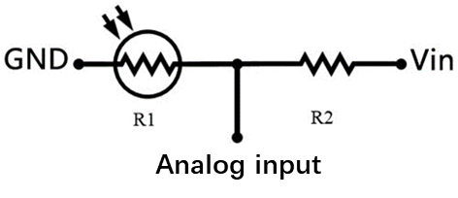

Figure 2. Connect photoresistor with ordinary resistor

Figure 3 and Figure 4 illustrate the principal diagram and experimental connection diagram of photoresistor, respectively. By building a circuit like Figure 4, we can read the divided voltage through input A0.

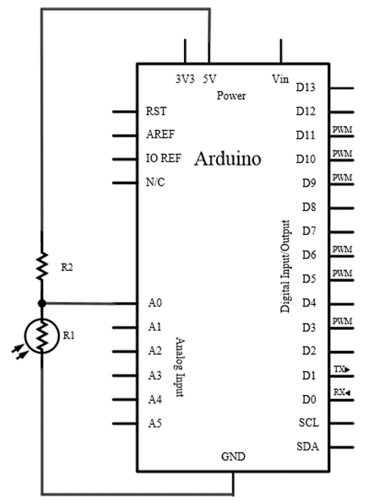

Figure 3. Principle diagram of photoresistor

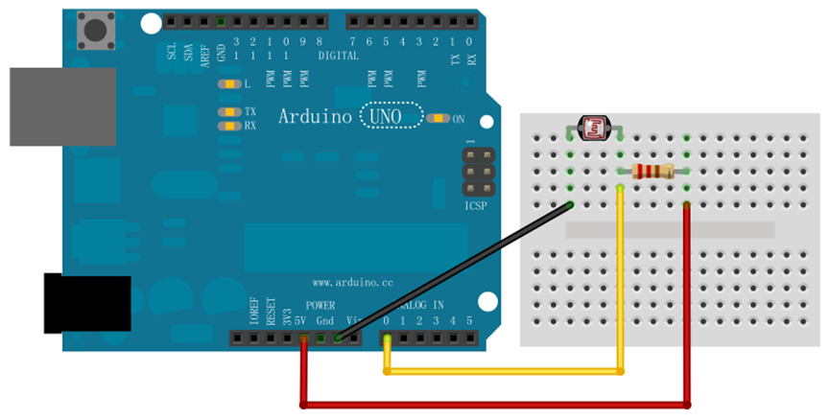

Figure 4. Experimental connection diagram of photoresistor

Run the attached program, select the current using board, and open the serial monitor, you can see the output information as shown in Figure 5, the Arduino outputs the current analog value read from the circuit through the serial port.

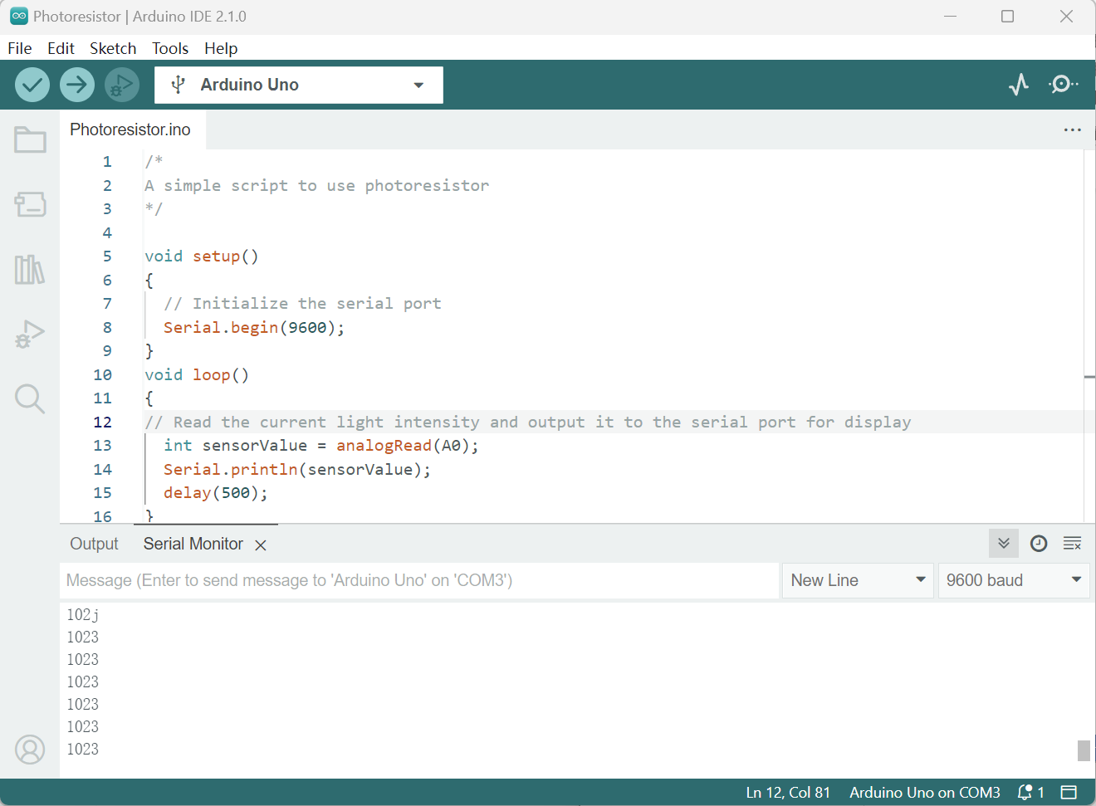

Figure 5. Interface of Arduino IDE